

Kk
CRITICAL EVALUATION OF ETHICAL AND LEGAL CHALLENGES IN DATA SCIENCE APPLICATIONS
Individual Project Assignment
Module: Mathematical and Ethical Foundation
Module Code: EAM03DS
Programme: MSc Data Science & AI
Student Name: Drashti Jigneshkumar Patel
Student ID: 10504966
Module Leader: Dr. Majdi Fanous
Month: September - 2026
Submission Date: 28th October 2026

Table of contents
Serial Number | Page Number | Topics
1 | 3 | Introduction
2 | 3 | Case Study Description
3 | 4 | Legal and Ethical Frameworks  Legal Considerations  Ethical and Professional Considerations
4 | 6 | Critical Evaluation and Mathematical Analysis  Method and Mathematical Approach  Racial Differences in Classification Errors  Threshold Sensitivity and Prediction Performance
5 | 11 | Competing Interpretations, Limitations and Wider Implications
6 | 12 | Proposed solutions and Mitigation Strategies
7 | 13 | Conclusion
8 | 13 | References

- Introduction
As data science becomes more widely applied, questions about algorithmic fairness, bias and accountability have become increasingly important. One example is COMPAS (Correctional Offender Management Profiling for Alternative Sanctions), a proprietary risk assessment system used in the United States criminal justice system. It is designed to assess the likelihood of a defendant being arrested again in the future. However, the use of such predictive tools raises concerns about whether their outcomes may lead to unequal or unfair treatment.
In a study by Angwin et al. (2016) COMPAS was analysed to look at cases within Broward County, Florida and found that there were racial disparities in false-positive and false-negative rates. This sparked discussion around whether these systems are fair to different demographics. Flores et al. (2016) criticised some elements of the ProPublica interpretation. It is therefore important to select appropriate statistical measures when evaluating fairness. This is relevant to data science ethics as unfairness can occur if predictions are inaccurate or not evenly distributed. This can impact individuals’ liberty and highlight issues with transparency, accountability and non-discrimination.
The COMPAS issue will be analysed in this report using legal, ethical and published research. This report presents a mathematical analysis of 7,214 defendant records. Firstly, the case will be described. Then, law, professional and ethical frameworks will be discussed. Mathematical findings will be analysed with alternative interpretations. Finally mitigation strategies will be suggested based on the evidence. Conclusions will be drawn to summarise what this means for responsible data science. Fairness, transparency and accountability are very important within high stakes algorithmic decision making.
- Case Study Description
COMPAS was created by Northpointe, now Equivant, to help support criminal justice decisions by predicting the risk of recidivism. It can help inform decisions around supervision, rehabilitation and sentencing, but it does not make decisions independently. Instead, it can influence professionals’ judgements when they consider the risk predictions.
Angwin et al. (2016) investigated over 7,000 defendants in Broward County, Florida, and found that Black defendants who were not rearrested within two years were more likely to be incorrectly classified as high risk. White defendants who were rearrested were more likely to be incorrectly classified as low risk. These findings raised concerns about differences in false-positive and false-negative rates between racial groups and whether the system treated defendants fairly.
However, these results have been contested. Flores et al. (2016) challenged aspects of ProPublica’s analysis and interpretation, arguing that the conclusions depended on the statistical methods and measures used to assess predictive performance. This highlights that fairness can depend on which statistical measures are selected and which consequences are prioritised. It also demonstrates why algorithmic fairness requires critical evaluation rather than relying on a single measure.
There are also legal implications surrounding COMPAS. The Wisconsin Supreme Court ruled that COMPAS could be considered during sentencing, subject to cautions and limitations (State v. Loomis, 2016). However, this ruling did not establish that the system was unbiased or that sentencing decisions should be based solely on its risk predictions.
This report analyses 7,214 records containing demographic information, risk scores and whether defendants were rearrested within two years. However, rearrest does not necessarily mean that a person committed a new offence. The outcome may also be affected by policing, monitoring and reporting practices. Therefore, the reliability of the target variable must be considered when evaluating the algorithm. These limitations are particularly important because predictions can influence high-stakes decisions affecting individuals’ liberty, making fairness, accountability and appropriate human oversight essential.
- Legal and Ethical Frameworks
- Legal Considerations
The Fourteenth Amendment to the Constitution of the United States of America includes provisions on Equal Protection and Due Process. The racial discrepancies within the COMPAS error rates raise concerns that there may be issues with fair treatment due to risk scores influencing sentencing decisions. However, statistical bias does not necessarily mean there is a breach of a Constitution, it must be taken into consideration along with the evidence.
The Wisconsin Supreme Court ruled in State v. Loomis [2016] that COMPAS could be used in sentencing but with some considerations. The Court recognised that the risk scores may not always be relied upon and expressed concerns regarding the lack of transparency with the proprietary software. It is therefore clear that it is important to ensure COMPAS is subject to some judicial review and defendants have a genuine opportunity to challenge the scores.
The applicability of data protection laws depends on the jurisdiction. The General Data Protection Regulation (GDPR) applies within the European Union, while the California Consumer Privacy Act (CCPA) is a California privacy law. Neither was the legal framework governing the Wisconsin COMPAS case. Therefore, the legal analysis of COMPAS should primarily focus on the Fourteenth Amendment to the US Constitution and the Wisconsin Supreme Court decision in State v. Loomis (2016). These demonstrate the importance of due process, appropriate safeguards and judicial oversight when algorithmic risk assessments influence sentencing decisions.
- Ethical and Professional Considerations
The Association for Computing Machinery Code of Ethics and Professional Conduct highlights how important it is to cause no harm, and ensure the system treats people fairly and without discrimination (Association for Computing Machinery [ACM], 2018). When using COMPAS this means developers should look into discrepancies in prediction errors and explain their limitations. Criminal justice institutions must also closely consider the scores.
The National Institute of Standards and Technology provide guidelines on identifying and mitigating risks associated with AI within their Artificial Intelligence Risk Management Framework. This states that systems should be valid, reliable, transparent and accountable (National Institute of Standards and Technology [NIST], 2023). This helps ensure the system can be independently assessed, tested across different demographics and monitored. Developers should mitigate any identified risks and institutions should ensure there is genuine human oversight.
The principle of non-maleficence means stakeholders should aim to prevent any unnecessary harm. False positives may cause overly restrictive decisions, whereas false negatives may cause underestimation of risk. However, rearrest is not an accurate measure of future offending behaviour so must be approached with caution. The principle of fairness should also be considered to ensure there is no unfair distribution of errors and their impacts. As the same numerical cut off is applied to everyone there is no guarantee that there will be equal error rates across different groups.
Using a consequentialist approach it is important to assess whether COMPAS provides more positive impacts in aiding risk assessments or negative impacts including unequal errors and unjustly restricting freedoms. Just because there are potential positive impacts doesn’t mean that unnecessary harm should be caused to a specific group. From a deontological perspective defendants should be treated fairly, valued as individuals and have genuine opportunities to challenge decisions.
These frameworks show there are responsibilities for stakeholders. Developers should ensure there are no discrepancies within the system by testing and explaining any limitations. Courts should closely consider the risk scores. Criminal justice institutions should monitor the outcomes. Although the discrepancies don’t necessarily mean there has been unlawful discrimination or wrongdoing, they show that the technical performance must be evaluated along with legal responsibilities, ethical obligations and real life impacts.
- Critical Evaluation and Mathematical Evaluation
- Method and mathematical approach
The 7214 defendant records were analysed to determine whether race, COMPAS decile_score and 2 year rearrest were related. Defendants were split into high risk and low risk based on whether their decile_score was greater than or equal to 5. The two_year_recid variable was used to determine if the defendant had been rearrested.
Note: This value has been chosen for this analysis. It does not correspond to the original High category in COMPAS. This must be done to prevent any misrepresentation of the original categorisation.
A confusion matrix was used to determine how accurate the model was at predicting the risk category of each defendant. There are 4 categories:
True Positive (TP): Defendant has been classed as high risk and was rearrested within 2 years.
True Negative (TN): Defendant has been classed as low risk and was not rearrested within 2 years.
False Positive (FP): Defendant has been classed as high risk but was not rearrested within 2 years.
False Negative (FN): Defendant has been classed as low risk but was rearrested within 2 years.
To evaluate the classification errors, the false-positive rate (FPR) and false-negative rate (FNR) were computed using the following mathematical expressions:
False Positive Rate:
$$FPR=\frac{FP}{FP+TN}×100$$
Using African-American group results:
$$\text{FPR}=\frac{805}{805+990}×100$$
FPR = 44.85%
False Negative Rate:
$$FNR=\frac{FN}{FN+TP}×100$$
Using African-American group results:
$$\text{FNR}=\frac{532}{532+1369}×100$$
FNR = 27.99%
The FPR describes the proportion of false positives (defendants who were not rearrested but were predicted to be a higher risk). The FNR describes the proportion of false negatives (defendants who were rearrested but were predicted to be less than a higher risk).
Overall accuracy was calculated to determine what proportion of predictions were correct:
$$Accuracy=\frac{TP+TN}{TP+TN+FP+FN}×100$$
$$Accuracy=\frac{2035+2681}{7214}×100=65.37\%$$
Accuracy = 65.37%
These are different measures of the predictive power of an algorithm. Accuracy gives a summary measure of how many instances are correctly classified. FPR and FNR provide information on different types of errors being made.
- Racial Differences in Classification Errors

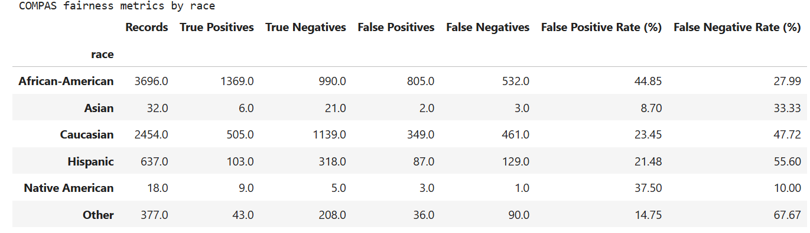
Table 1: Classification error rates by race
The FPR for African Americans is larger (44.85%) than for Caucasians (23.45%). This can be seen below:
$$ΔFPR=FPR_{AA}-FPR_{Caucasian}$$
$$=44.85\%-23.45\%$$
$$ΔFPR=21.39\%$$
This shows that significantly more African American defendants have been identified as high risk despite them having no documented re-arrests. The Caucasian group however had a higher FNR of 47.72% compared to 27.99%.
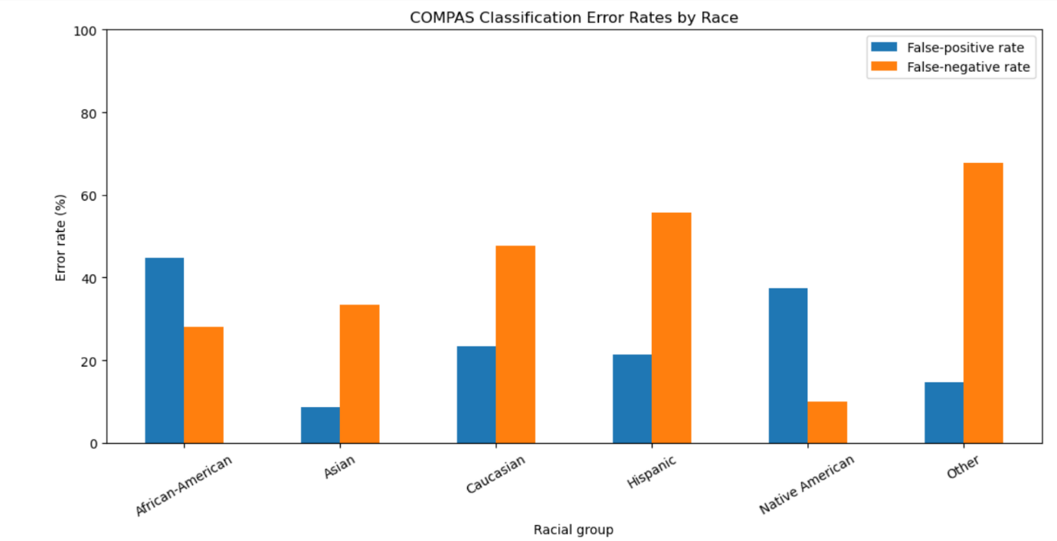
Figure 1: COMPAS Classification Error Rates by Race
The results indicate differences in errors made by the different racial groups. This could be due to false positives, leading to overly stringent decisions, or false negatives, leading to
underestimation of risk. Whilst this table provides evidence of a fairness issue there is no evidence that all classifications were incorrect or that only race was a factor.
A two-sample z-test was carried out to determine whether there was a significant difference between the false positive rates of the African-American group and the Caucasian group.
Pooled Proportion =
$$\hat{p}=\frac{FP_{1}+FP_{2}}{n_{1}+n_{2}}$$
$$Z=\frac{p_{1}-p_{2}}{\sqrt{\hat{p}\left(1-\hat{p}\right)\left(\frac{1}{n_{1}}+\frac{1}{n_{2}}\right)}}$$
Where:
1. (p_1) : African-American FPR
2. (p_2) : Caucasian FPR
3. (\hat{p}) : Pooled false positive proportion
4. (n_1), (n_2) : Number of defendants with no record of rearrest
The uncertainty surrounding the difference between the two false-positive rates was assessed by calculating a 95% confidence interval using the following expression:
$$\left(p_{1}-p_{2}\right)±1.96\sqrt{\frac{p_{1}\left(1-p_{1}\right)}{n_{1}}+\frac{p_{2}\left(1-p_{2}\right)}{n_{2}}}$$
The result seen were :
Z = 12.78
$$p=2.11349×{10}^{-37}$$
The approximate 95% confidence interval is between 18.24 and 24.54 percentage points. Since this range does not include zero, there is strong statistical evidence against the null hypothesis that the FPRs are equal.
However, this doesn’t necessarily indicate any of these. We can conclude that there is evidence for a difference, but not why.
Extra care must be taken when interpreting the estimates from the smaller groups. The Asian group has 32 records and the Native American group has only 18. This means our estimates aren’t as accurate. Therefore, they shouldn’t be considered as representative of the population. Confidence intervals and sample sizes are therefore very important in avoiding overconfidence in our results due to having a low amount of data.
- Threshold Sensitivity and Predictive Performance
The discrimination threshold determines whether the risk score of COMPAS will be classified as high risk or not. The discrimination rule for this analysis is:
$$\hat{y}=\left\{\begin{matrix}1, & \text{if decile score}≥t \\ 0, & \text{if decile score}<t\end{matrix}\right.$$
Where,
1. \hat{y} = 1 indicates a high risk prediction.
2. \hat{y} = 0 indicates not a high risk prediction.
3. t indicates the discrimination threshold.
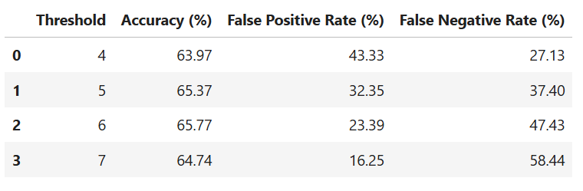
Table 2 : Overall performance at different classification thresholds
Increasing the threshold generally reduces the FPR while increasing the FNR. At threshold 7, the FPR falls to 16.25%, but the FNR rises to 58.44%. Accuracy reaches approximately 65.77% at threshold 6, but this does not automatically make threshold 6 the most ethical choice.
The trade-off is important because reducing one type of error can increase another. A lower FPR may mean fewer defendants without recorded rearrest are classified as high risk, while a higher FNR means more defendants with recorded rearrest are classified below the threshold. The appropriate balance depends on the intended use of the assessment, the consequences of each error and the safeguards available.
The analysis also compared the selected threshold with COMPAS’s original high-risk category. The condition decile_score >= 5 classified 3,317 defendants as high risk, whereas score_text == "High" classified 1,403 defendants as high risk. The two approaches classified 1,914 records differently. This demonstrates that analytical choices can materially change the results and reinforces the need to state the threshold explicitly.
Accuracy alone is therefore an inadequate measure of fairness. A system may achieve similar overall accuracy while distributing errors unequally across groups. Threshold selection should be justified by evidence, the intended decision and the potential harm to affected individuals rather than by selecting whichever value produces the highest accuracy.
- Competing Interpretations, Limitations and Wider Implications
Whilst ProPublica highlighted racial differences in the error rates, the methodology used was questioned by Flores et al (2016) using alternative statistical criteria. This shows how there is no one measure to determine fairness in algorithms. As Chouldechova (2017) explains, when different outcome rates are observed between groups and there is a non-perfect predictor, fairness measures such as equal false positive/negative rates and equal predictive value can not generally be achieved at the same time.
Whilst this presents complications in trying to achieve fairness, it is important for decision makers to consider what aspects of fairness they wish to achieve and provide justification for the trade-offs made. Even if similar predictive values are prioritised, this does not necessarily mean that there will be equal FPRs. If the aim is to achieve equal error rates this could impact on other aspects of performance. It is important to have clear reasoning behind which approach will be taken.
There is also a complication with the outcome. Whilst rearrests are recorded, this does not necessarily mean that the individual has been shown to have re-offended. Different levels of policing, monitoring and recording could lead to bias in the data. This means that whilst the model has been accurately evaluated using the recorded outcome, this may not actually be a good representation of the true outcomes. This issue can not be solved by improving statistical modelling.
As COMPAS is a proprietary algorithm there is limited opportunity for independent evaluation. This can make it difficult for defendants to understand and challenge their assessment. Whilst having human oversight may seem like a good safeguard, decision makers may be inclined to follow the recommendations given by the algorithm, especially if they do not have the knowledge or information to critically evaluate it.
The Dutch childcare benefits scandal can provide some insight into this issue. There were instances of discriminatory profiling linked to algorithm use in the Dutch childcare benefits system (Amnesty International, 2021). Whilst the legal and institutional setting is different to COMPAS, this demonstrates the risk of allowing algorithmic classifications to influence consequential decisions without enough transparency, accountability and good safeguards.
Overall the mathematical analysis has shown there is a significant level of racial disparity based on the chosen threshold. However, this does not provide any independent reasoning for why this disparity has occurred. A justifiable evaluation must take into consideration the statistical evidence, careful interpretation of outcome, trade-off between fairness criteria, legal requirements and consequences of errors.

- Proposed solutions and Mitigation Strategies
Conduct independent and repeated audits on the fairness of your system. This could include looking at FPR and FNR values as well as predictive performance within different demographic groups. Audits should provide details on sample sizes and confidence intervals. If large inequalities are found then this should be investigated. Alternative threshold values should also be tested. Institutions should decide on what actions will be taken based on audit results.
Improve the quality of data and validity of outcomes. Developers should be aware of where data has come from, how it was collected and any limitations. Rearrest should not be taken as a definitive result. Sensitivity analyses should be conducted to see if any assumptions affect the conclusions. The NIST (2023) framework can be used to help identify and monitor these risks.
Ensure clarity and human oversight. Judges and correctional professionals should understand what a score is being used for, how it was validated and any limitations. Risk scores should not be the only or main factor when determining sentencing (State v. Loomis, 2016). If there are issues with looking into the tool due to proprietary issues then authorities should consider whether it can be used responsibly.
Ensure accountability and contestability. An institution should decide who is responsible for monitoring performance, handling complaints and reviewing adverse outcomes. There should be real opportunities for those impacted by errors to challenge them. Those impacted should understand how they have been assessed and how this affects decision making. A multi-disciplinary team including statisticians, legal professionals, ethicists and those impacted can help identify risks that may not be identified through technical testing.
There can be issues with implementing audits. These can be resource intensive, there may be issues with transparency due to commercial interests and human oversight may be influenced by the algorithm. Training staff, having clear roles and independent reviews will help. Whilst there isn't one solution to completely remove all biases, using technical measures alongside an accountable institution can help reduce avoidable harm.

- Conclusion
A legal, ethical and mathematical investigation was performed to understand the bias in the COMPAS algorithm. The dataset of 7214 records was analysed with the decile_score >= 5 decision threshold. An FPR of 44.85% was identified for African-American defendants and 23.45% for Caucasian defendants. The statistical testing showed that there was a large difference between the two groups but did not identify why this was happening or show evidence of unlawful discrimination.
It shows that accuracy does not ensure an ethical algorithm. This is due to imperfect outcomes, different definitions of fairness, different error rates and little explainability. These factors can be reduced by introducing independent auditing, accurate outcome measurement, meaningful human control and good ways to question decisions. Overall responsible data science requires accurate predictions but also justified, explainable and accountable decisions.

References
Amnesty International. (2021, October 25). Xenophobic machines: Discrimination through unregulated use of algorithms in the Dutch childcare benefits scandal. https://www.amnesty.org/en/documents/eur35/4686/2021/en/
Angwin, J., Larson, J., Mattu, S., & Kirchner, L. (2016, May 23). Machine bias. ProPublica. https://www.propublica.org/article/machine-bias-risk-assessments-in-criminal-sentencing
Association for Computing Machinery. (2018). ACM code of ethics and professional conduct. https://www.acm.org/code-of-ethics
Chouldechova, A. (2017). Fair prediction with disparate impact: A study of bias in recidivism prediction instruments. Big Data, 5(2), 153–163. https://doi.org/10.1089/big.2016.0047
Flores, A. W., Bechtel, K., & Lowenkamp, C. T. (2016). False positives, false negatives, and false analyses: A rejoinder to “Machine bias: There’s software used across the country to predict future criminals. And it’s biased against blacks.” Federal Probation, 80(2), 38–46. [Add the verified URL for the article if you accessed it online.]
National Institute of Standards and Technology. (2023). Artificial intelligence risk management framework (AI RMF 1.0) (NIST AI 100-1). https://doi.org/10.6028/NIST.AI.100-1
State v. Loomis, 881 N.W.2d 749 (Wis. 2016). https://law.justia.com/cases/wisconsin/supreme-court/2016/2015ap000157-cr.html

